Acta Acustica®, The Journal of the European Acoustics Association

goes back to the future

Starting from January 2020, important changes will occur in the journal of the European Acoustics Association (EAA): our journal will become a full Open Access Journal.
Thus our Journal will have an increased citation and usage, a greater public engagement, faster impact, wider collaboration.
Thus, for the benefit of its 9000 members, the EAA will be in full accordance with the plan S (https://www.coalition-s.org/ ) established by 16 European Funding Agencies (incl. the EC) and imposing the publication of research results in full open access journals, starting in January 2021.
To fulfil this important objective, additional changes have been necessary, namely going back to the original title of the journal (ACTA ACUSTICA®) and moving to EDP Science, actually the former publisher in 1993-95. The press release is available at the following link:
https://www.edpsciences.org/en/news-highlights/1830-open-access-acous
The main change related to Open Acces is that the cost of publication is transferred from the journal subscribers to the authors of articles.
Being aware of this, the EAA has set up a support scheme, based on the solidarity principle among the National Societies. The scheme provides to the EAA member authors financial support to pay the required Article Processing Charge (APC) as detailed hereafter.
ACTA ACUSTICA®, with its reknown reputation since 1993, will be the suitable on-line platform for all acousticians to disseminate their work worldwide.
Don’t miss this opportunity to become active for co-creating participative science

Prof. Jorge Patricio
EAA president

OPEN ACCESS
APC (Article Processing Charge)
EAA provides support to its members publishing papers on Acta Acustica® full Open Access
by means of an economic contribution to the Article Processing Charge (APC) payment, in accordance with the procedure set in the flow chart below. The values established for 2020 as follows:

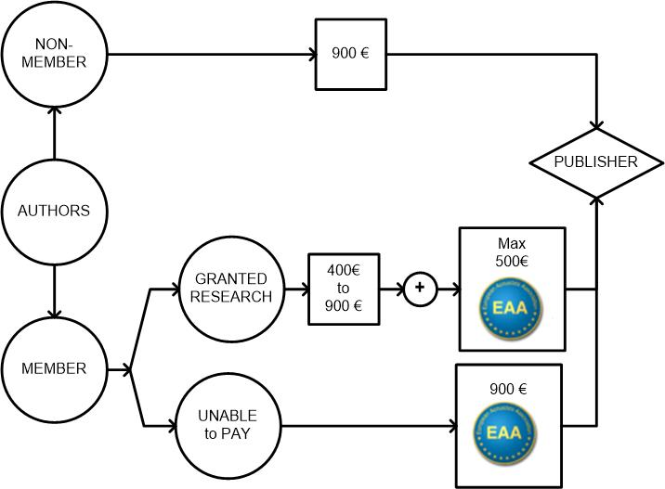
Two categories of EAA member authors are defined:
1) without any grant for APC, i.e. authors without any affiliation to an institution, or that their institution does not accept the APC as an expense;
2) partially granted for APC from other funders.

The procedure is structured into three steps as follows:
a) At the time an article has been accepted for publication, the EAA member corresponding author applies to her/his National Society in case she/he needs financial support for APC (no grant or partially granted). In any case the author must declare on her/his liability one the following clauses:
- either having no affiliation to an institution or that this institution does not accept the APC as an expense (category 1);
- having other funders, to be specified together with the amount of grant already available (category 2).
b) The National Society of the applicant will transmit the above request and the information to the EAA General Secretary together with certification of her/his affiliation for at least the last three years.
c) If the above requirements are met, the EAA General Secretary will inform the corresponding author and the publisher of the amount of financial support granted by EAA.

The EAA Board settles the APC contribution rates and revises them annually. For 2020 the EAA contribution rates are:
1) 900€ (+VAT) of APC for EAA authors without any grant (category 1);
2) maximum of 500€ (+VAT) for EAA authors having other funders (category 2).
The financial contribution will be paid by EAA to the EDP publisher that, at the agreed schedule, will invoice EAA for the amount of the EAA granted papers.

